Parallel Structure
Sentence elements that are alike in function should also be alike in construction. These elements should be in the same grammatical form so that they are parallel.
Using parallel structure in your writing will help with
1) economy 2) clarity 3) equality 4) delight.
Here are some examples of parallel elements
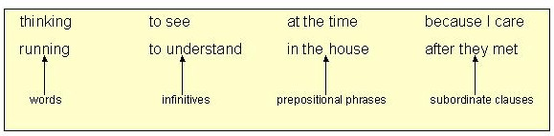
These elements, on the other hand, are not parallel
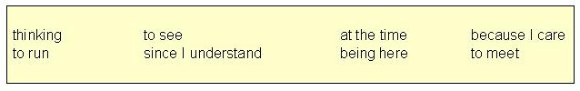
Used in a sentence, they create a jarring effect and produce writing with unclear emphasis and meaning. We call such an error "faulty parallelism."
Writers generally use parallelism as a technique in the following five ways.
1. With elements joined by coordinating conjunctions, especially and, but, and or.
Coordinating Conjunctions:
And, Or, But, Nor, Yet, So, For
Examples of parallel words
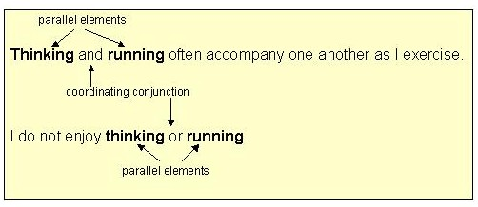
Examples of parallel phrases
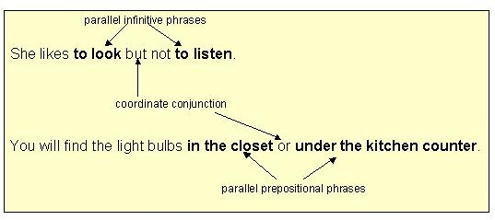
Examples of parallel clauses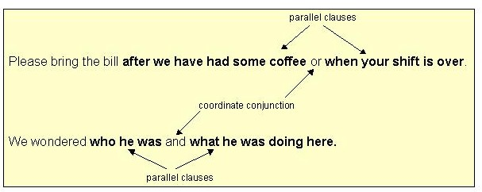
The examples below show how to repair faulty parallelism.
Example1 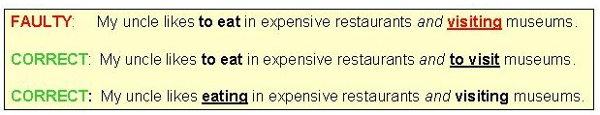
Example #2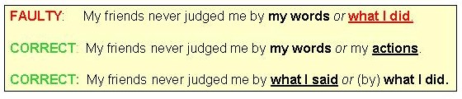
Sentence Parallel Structure - Exercise 1
Directions: Each sentence below contains faulty parallelism with coordinate conjunctions. Revise each sentence so that the elements joined by the coordinate conjunction are parallel to one another.
1. What I said or my actions upset everyone in the room.
2. She suggested that I write a memoir and to send it to a good publisher.
3. The instructor advised me to use the rearview mirror often, and I should observe the speed limit.
4. People are paying more now for health insurance but to get less coverage.
5. Doing strenuous exercise and poor nutrition habits can lead to illness.
PART TWO
2. Use parallel structure with elements in lists or in a series.
A series is a group of three or more elements in a row. The last element in the series is connected to the others with one of these coordinating conjunctions: and, or, but (not), or yet (not).
Commas should be placed between each element in the series and before the coordinating conjunction.
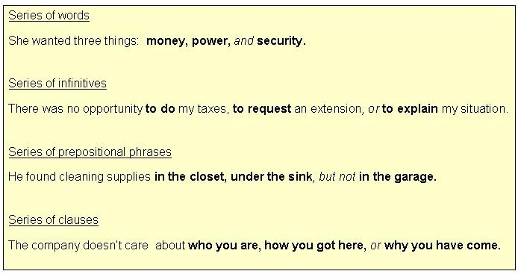
Examples of series
As the examples below show, a series whose components are not in parallel format sounds awkward and may cause misunderstanding.
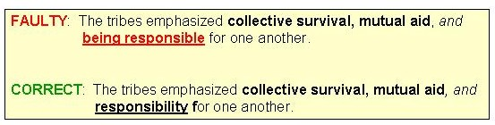
Example #1

Example #2
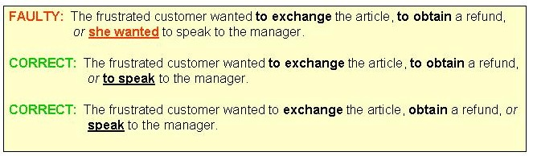
Note that in the corrected versions of example #2, you may choose to repeat the "to" or to omit it.

Sentence Parallel Structure - Exercise 2
Directions: Each sentence below contains faulty parallelism with elements in a series. Revise each sentence so that the elements are parallel to one another.
Write your answers in the space provided under each item. When you have completed the exercise, click on "Check My Answers" and check your answers with those on the answer key.
1. At the store my duties are to keep the shelves stocked, to work the registers, and assisting customers.
2. Later that day, Mike took the fishing rods to the lake, caught several fish, and he fell asleep.
3. The nanny was supposed to feed the children, walk the dog, and some dusting in the living room.
4. The condominium board's goals include building up a reserve fund, keeping the community informed, and property assessment.
5. Our baseball coach taught us how to hit, tag out runners, and base stealing.
6. We want a candidate who has a sense of commitment, a good record in public office, and who has experience in foreign affairs.
PART THREE
3. Use parallel structure with elements being compared. (X is more than / better than Y)
When we compare things, we often use words such as more, less, better, and worse, We connect the items being compared with words likeas and than.
Note the comparison methods in the examples below.
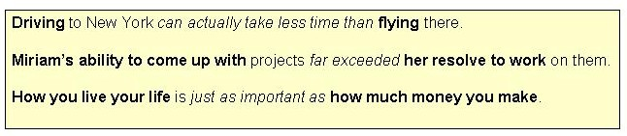
The elements being compared are parallel to one another:
driving is parallel to flying
Miriam's ability to is parallel to her resolve to
How you live is parallel to how much money you make
Comparing items without using parallel structure may cause confusion about what is being compared to what.
Repair faulty parallelism in comparisons by making one element of the comparison parallel to the other.
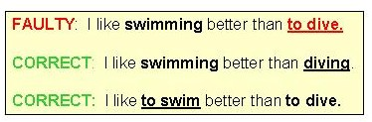
Note that you may choose to change either element to match the other.

Sentence Parallel Structure - Exercise 3
Directions: Each sentence below contains faulty parallelism with elements in a comparison.. Revise each sentence so that the elements are parallel to one another.
1. It is harder to tie a slip knot than tying a square knot.
2. Driving will get you there more quickly than to walk.
3. A big car is not necessarily better than one that is small.
4. Hearing her sing in person was ten times better than if you heard her on the radio.
5. Her excuses bothered me more than she was absent.
6. It is better to learn the material slowly than cramming on the night before the test.
PART FOUR
4. Use parallel structure with elements joined by a linking verb or a verb of being.
Joining elements with linking verbs or verbs of being suggests a completing of the first item by the second one. Often, in fact, an equality between the two is being set up, as the examples below illustrate.
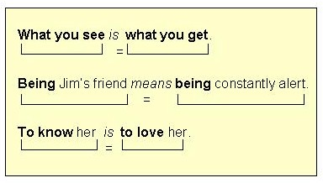
Repair faulty parallelism with linking verbs or verbs of being by making one element of the equation parallel to the other.
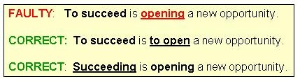

Sentence Parallel Structure - Exercise 4
Directions: Each sentence below contains faulty parallelism with elements joined by linking verbs. Revise each sentence so that the elements are parallel to one another.
1. To take the fifth amendment is refusing to incriminate yourself.
2. What she said was her meaning.
3. Doing well on the GRE means to assure yourself acceptance into a good graduate school.
4. Many people mistakenly think that being wealthy is the same thing as to be happy.
5. Marrying Major Boundy meant to leave her family and to travel all over the world..
PART FIVE
5. Use parallel structure with elements joined by a correlative conjunction.
These are the major correlative conjunctions:
either / or neither / nor both / and not only / but also
Correlative conjunctions work in pairs.
Whatever grammatical structure follows one must be parallel to the grammatical structure that follows the other.
Examples with either / or and neither / nor
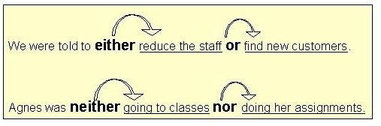
Examples with both / and
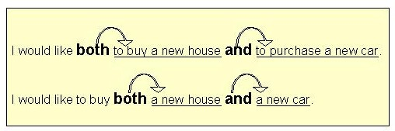
Examples with not only / but also
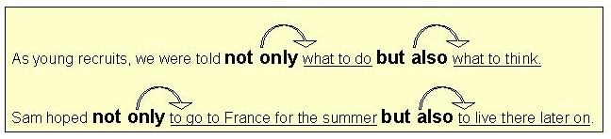

Repair faulty parallelism with correlative conjunctions by making one structure parallel to the other as shown below.
With either / or
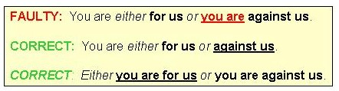
With neither / nor
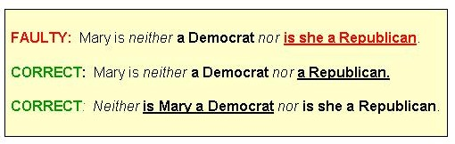
With both / and
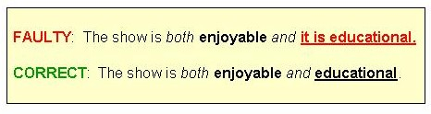
With not only / but also
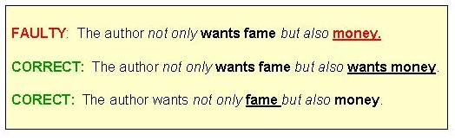

Sentence Parallel Structure - Exercise 5
Directions: Each sentence below contains faulty parallelism with correlative conjunctions.. Revise each sentence so that the elements are parallel to one another.
1. Either ask Ben or Marianne to prepare the agenda for tonight's meeting.
2. My friends are neither anxious to see the items in the museum nor are they happy about the admission price.
3. She is both happy about the raise and she is nervous about the extra responsibility.
4. They not only ate all the food in the house but they also didn't clean up their mess.
5. Bert will meet us either at the restaurant or he will be at the taxi stand.
6. The doctor promised neither to cause pain during the procedure nor leave a scar.

Remember: Parallelism in sentence construction helps to create economy, rhythm, emphasis, and clarity in your writing. Use this writing technique to your advantage!

