Major Comma Uses
© 2005, 2002, 1987 Margaret L. Benner All rights reserved.
COMMA RULE #1 – THE COMMA IN A SERIES: Use commas to separate items in a series.
What is a ”series”?
A “series” is a list of 3 or more items, the last two of which are joined by and, or, or nor.
_____________, ______________, and _____________
EXAMPLES:
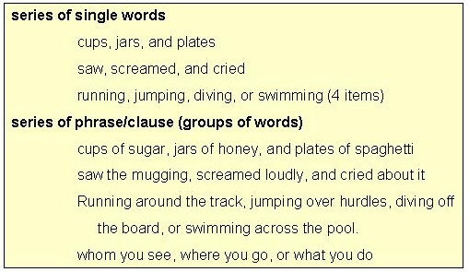

The important things to remember about using commas in series are these:
1. A series includes 3 or more items of the same type (words or groups of words).
2. The series is connected by and, or, or nor before the last item.
3. A comma separates items in the series, including the final item preceded by and, or, or nor.
Exercise 1 - Directions: Rewrite the below sentences, placing commas where commas are needed. If a sentence needs no comma, write "correct".

1. The English professor adjusted her glasses shuffled her notes and began her lecture.
2. A jogger ran down the alley and onto my lawn this morning.
3. She stepped around the grass across the sidewalk and onto the curb.
4. Neither rain sleet nor hail shall keep away the U.S. mail.
5. A glass of milk a cup of tea or a mug of coffee will be fine.
COMMA RULE #2 – THE COMMA WITH COORDINATE ADJECTIVES: Use commas between coordinate adjectives.
What are “coordinate adjectives”?
“Coordinate adjectives” are adjectives placed next to each other that are equal in importance.
Two tests to determine whether adjectives are coordinate are the following:
1. See whether “and” can be smoothly placed between them.
2. See whether the adjectives’ order can be reversed.
Look at this example.
In this example, a comma belongs between happy and lively because they are coordinate adjectives.
Test to make certain:
First, try the “and” test.
And placed between the 2 adjectives sounds smooth.
Second, try reversing the adjectives.
When the adjectives are reversed, the sentence still makes sense.
Thus, happy and lively are coordinate adjectives in the example and should be separated by a comma.

CAUTION: Not all adjective pairs are coordinate adjectives. Thus, not all adjectives should be separated from one another by a comma.
Look at this example.
In this example, no comma belongs between the two adjectives young and golden because they are not coordinate adjectives.
How can we know?
First, try the “and” test.
And placed between the two adjectives does not fit smoothly.
Second, try reversing the adjectives.
When the two adjectives are reversed, they do not make sense.
Thus, young and golden are not coordinate adjectives and should not be separated by a comma.
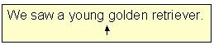
Exercise 2 - Directions: Rewrite the below sentences, placing commas as needed between all coordinate adjectives. If the adjectives in the sentence are not coordinate (apply tests), then do not add commas, but write "correct".

1. We enjoyed the clean crisp smell of the mountain air.
2. Beth was a student whose intelligent conscientious mind earned her good grades.
3. Dr. Bean gave us a hard final examination.
4. She ate the sweet juicy apple with a vengeance.
5. The awkward shy teenager felt nervous about his first date.
COMMA RULE #3 – THE COMMA IN A COMPOUND SENTENCE: Use a comma before and, but, or, nor, for, so, or yet to join two independent clauses that form a compound sentence.
What is a compound sentence?
A compound sentence is a sentence that has 2 independent clauses.
An independent clause is a group of words with a subject and verb that expresses a complete thought. It is also known as a simple sentence. An independent clause can stand alone as a sentence.
The two independent clauses in a compound sentence can be joined by:
A. Semicolons
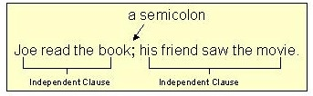
OR
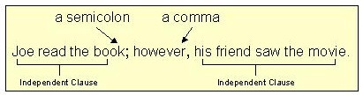

B. A comma and one of the seven joining words: for, and, nor, but, or, yet, and so. (Taken together, the first letters spell “FANBOYS.”)
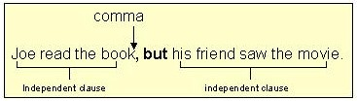
This last type of compound sentence is the one we will concentrate on for comma use.
A compound sentence must have two independent clauses – not just two verbs, two nouns, or two groups of words that are not independent clauses.
Look at this example.
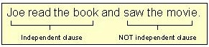
In the above example, two verb groups are being joined by and. The second verb group does NOT have a subject; thus, it is NOT an independent clause.
Therefore, NO comma belongs before and.
This example is a simple sentence with a compound verb, not a compound sentence.
However, we can make this sentence into a compound sentence by simply making the last verb part into an independent clause.
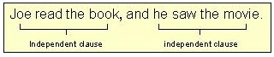
Now we have a “bona fide” compound sentence. The two independent clauses are separated by a comma and the word and.
Here are some other examples which illustrate the difference between compound elements in simple sentences (no comma) and true compound sentences (comma).
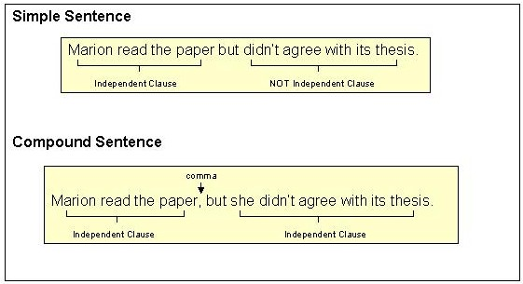
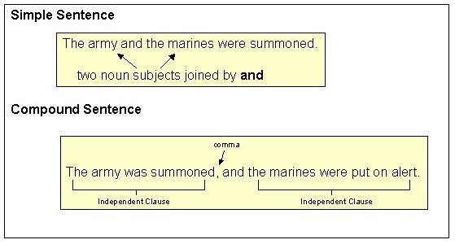
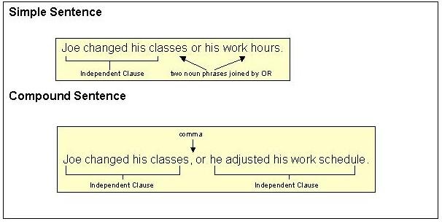
Now you are ready to try an exercise.
Make certain that you:
1. Know the seven joining words (for, and, nor, but, or, yet, so).
2. Can distinguish between simple sentences with compound elements (no comma) and compound sentences (comma).

Exercise 3 - Directions: Rewrite the below sentences, placing commas where commas are needed. If a sentence needs no comma, write "correct".

1. You must go immediately or you will not get a place in the class.
2. I am copying this recipe for I want to make this dish someday.
3. Harold fed the cats and walked the dog.
4. He will be elected tomorrow and he will be a good leader.
5. This class is exciting but it is hard.
COMMA RULE #4 – THE COMMA WITH INTRODUCTORY WORDS: Place a comma after introductory phrases that tell where, when, why, or how.
Specifically . . . use a comma:
1. After a long introductory phrase.
Example:
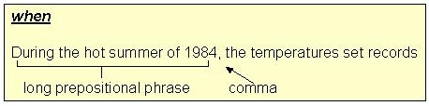
Usually, it is NOT necessary to use a comma after short introductory prepositional phrases.
Example:
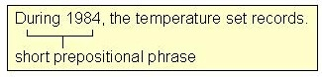
2. After an introductory phrase made up of “to” plus a verb and any modifiers (“infinitive”) that tells why.
Example:
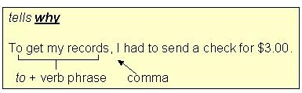
Use a comma even after a short “to” + verb phrase that answers why.
Example:
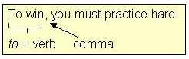
You can tell you have this kind of introductory “to” + verb phrase when you can put the words “in order” in front of the phrase.
Example:
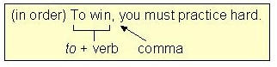
Be careful! Not all introductory “to” phrases tell why.
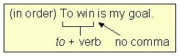
3. After an introductory clause that answers
when? where? why? how? to what degree?
(A “clause” is a group of words with a subject and a verb.)
Examples:
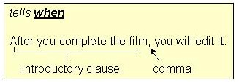
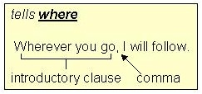
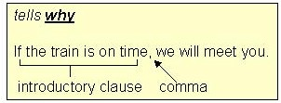
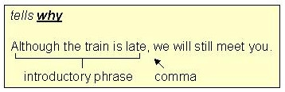
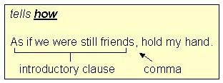
NOTE: When such a clause comes at the end of a sentence, do NOT use a comma.
Examples:
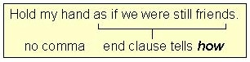
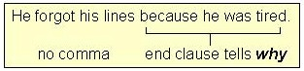
Exercise 4 - Directions: Rewrite the below sentences, placing commas where commas are needed. If a sentence needs no comma, write "correct".

1. Because she did not consult her calendar Merrill missed her date.
2. I am copying this recipe because I want to make this dish someday.
3. To earn an “A” in Dr. Long’s course one must work very hard.
4. After many days at the mine the workers were tired and angry.
5. As though nothing had happened she sat down comfortably.
MA RULE #5 – THE COMMA WITH NONESSENTIAL WORDS, PHRASES, AND CLAUSES: Separate with a comma any nonessential words or groups of words from the rest of the sentence.
1. Separate “interrupter” words like however, nevertheless, yes, no, of course, from the rest of the sentence.
Examples:
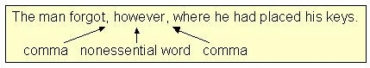
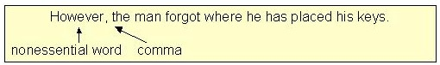
2. Separate a “renamer” (an appositive) from the rest of the sentence with a comma.
Example:
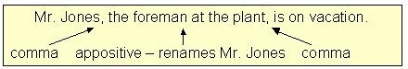
3. Separate adjective phrases from the essential parts of the sentence.
(An “adjective” describes or limits a noun.)
Examples:
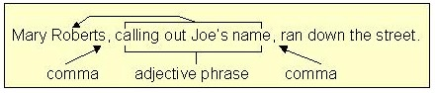
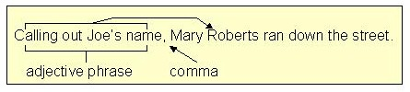
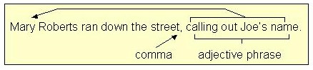
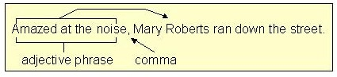
In each instance above, “Mary Roberts ran down the street” comprises the essential part of the sentence. The adjective phrases are nonessential and should be separated from the rest of the sentence with commas.
4. Separate nonessential adjective clauses from the rest of the sentence.
There are two kinds of adjective clauses:
- one that is needed for the sentence to be complete (ESSENTIAL)
- one that is NOT needed for the sentence to be complete (NONESSENTIAL)
The essential adjective clause should NOT be separated from the sentence with commas.
The nonessential adjective clause (like other nonessential elements) SHOULD be separated with commas.
Two examples illustrate the difference:
A.
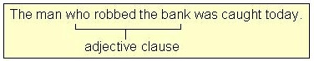
B.
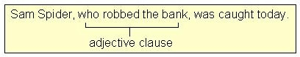
Look at example A. If we remove the adjective clause “who robbed the bank,” the sentence reads, “The man was caught today.” Without the adjective clause (“who robbed the bank”), we do not know which man was caught. Thus, the adjective clause is needed to complete the sentence’s meaning. In other words, this adjective clause is essential. As the rule notes, do not use commas around essential adjective clauses.
Now look at example B. If we remove the adjective clause “who robbed the bank,” the sentence reads, “Sam Spider was caught today.” Without the adjective clause (“who robbed a bank”), we do know which man was caught (Sam Spider). Thus, the adjective clause is NOT needed to complete the sentence’s meaning. In other words, this clause is nonessential. Following the rule, you should separate this adjective clause from the rest of the sentence.
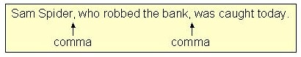
REMEMBER, there are 4 nonessential elements that should be separated from the rest of the sentence with commas:
1. “interrupter” words like of course, however
2. “renamers” (appositives)
3. nonessential adjective phrases
4. nonessential adjective clauses
Directions: Rewrite the below sentences, placing commas where commas are needed. If a sentence needs no comma, write "correct".
1. Recognizing the thief the policemen arrested him immediately.
2. The student who writes the best paper will receive the best grade.
3. Elias Moxley a famous trial lawyer will represent Ms.Tishman.
4. Mary realizing her bad situation tried to convince her boss to give her a raise.
5. Bees for example have four wings.

