Avoiding Fragments
The sentence, like many other things, is a large item composed of smaller items. Considered as a large item, it is sometimes difficult to understand. Therefore, we will begin with the smallest, simplest elements that make up a sentence, gradually moving toward the large, more complicated ones.
WORDS
A word is the smallest part of speech and the easiest element of speech to recognize.
EACH GROUP OF LETTERS IN THIS SENTENCE IS A WORD.
There are different kinds of words, according to the particular part a given word plays when it is used in speech (writing or speaking). To each kind of word we assign a label that shows which part of speech that word is.
As you may already know, there are eight parts of speech.
noun verb adverb conjunction
pronoun preposition adjective interjection
We will consider three of them in this unit: noun, pronoun, and verb.
NOUNS
A noun names a person, place, thing, or idea.
A noun may name a type of person, place, thing, or idea.
Nouns that name particular persons, places, things, or ideas are proper nouns. Proper nouns are capitalized.
**NOTE: Words that name ideas are sometimes hard to recognize as nouns because they name abstract ideas that we cannot see. These are abstract nouns (e.g. time, imagination, judgment, October, Saturday).
Even though these words name things we cannot see, they are still nouns because they name something.
PRONOUNS
A pronoun is a word that may substitute for a noun.
VERBS
A verb shows an action or a state of being.
Action verbs are easy to recognize.
Some examples
This sentence uses an action verb.
drew = action verb
Verbs that show state of being indicate that something or someone exists.
Some examples
These sentences use verbs of being.
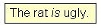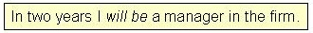
is = verb of being will be = verb of being

Parts of speech do not just sit idly about without any purpose. They have specific tasks to perform when they are put together in a sentence.
Look at this sentence.
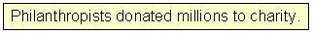
There are three nouns in this sentence: philanthropists, millions, and charity.
The action in this sentence is expressed by the verb – donated.
Although there are three nouns in this sentence, only one of them is actually DOING the action of donating: philanthropists.
Philanthropists donated…
We could also express this same idea with a pronoun.
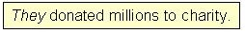
Here the pronoun they is DOING the action of donating.
They donated…
The two sentences above illustrate a rule of sentence structure:
When a noun or pronoun is partnered with a verb so that the noun or pronoun is doing the action expressed by that verb, we call that noun or pronoun the verb’s SUBJECT.
Sometimes a verb will express being or existence instead of action.
Look at this sentence.
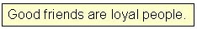
The verb in this sentence -- are – does not express action.
Instead, it expresses being or existence – tells us that something is alive.
Still, as in the earlier sentences, there is a noun paired with this verb. That noun is the one DOING the existing or being: friends.
Good friends are…
This noun – friends – is the subject of the verb are in this sentence.
As we did with the action verb example, we could substitute a pronoun for the noun, friends, in this sentence.

Knowing that verbs can express either action or being, we can now expand our rule.
When a NOUN or PRONOUN is paired with a verb so that the noun or pronoun is doing the action or the being expressed by the verb, we call that noun or pronoun the verb’s SUBJECT.
**SPECIAL NOTE: Sometimes we use sentences in which a subject is not actually stated, but is, nevertheless, understood in the meaning.
Example
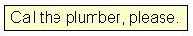
A sentence like this gives an order or a request to someone.
What we really mean when we make such requests is shown in the sentence below.
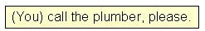
You, as the DOER of the action verb, call, is the SUBJECT here.
Because we use such statements when we are talking directly to someone, we usually omit the word you. We consider it unnecessary –understood in the sentence.
Therefore, in statements such as -- Call the plumber, please -- we say that the subject is
you (understood)
you (understood) = subject
This kind of sentence is called an imperative sentence.
Exercise 1
Directions: Pick out the subject in each of the sentences below and write the word on the given line.

1. After the dance, Cinderella ran home as quickly as possible.
2. At night, I am a very poor driver.
3. Many residents lost their homes during the hurricane.
4. Every Monday he drives his children to school.
5. They found the correct answers.
PART 2
Now you know how to locate the subject in a noun-verb partnership: look for the noun (or pronoun) that is DOING the action or the being expressed by the verb.
The verb in this noun-verb partnership also has a job to do. It functions as the action or as the being that the subject is DOING.
Look at these examples.
1.
2.
We already know that the noun philanthropists, the DOER of the action, donated, is the subject of the noun-verb partnership, philanthropists donated (example #1).
We also know that the noun friends is the subject of the noun-verb partnership, friends are (example #2).
These verbs – donated and are – also perform a specific task in this noun-verb partnership: they express the subject’s action or state of being.
We call a verb that performs this function a predicate.
Philanthropists = subject
donated = predicate
friends = subject
are = predicate
you (understood) = subject
call = predicate
The verbs in the sentences below are also doing the job of a predicate.
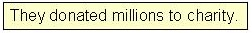 they = subject
donated = predicate
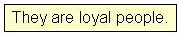 they = subject
are = predicate
This information leads us to a rule:
The VERB in a noun/pronoun – verb partnership expressing the action or being of the subject is a PREDICATE.
Sometimes the predicate will be composed of two or three verbs that fit together -- the main verb preceded by one of more helping verbs.
Helping verbs (also called auxiliary verbs) help the main verb to form its tense (time) or to emphasize its action. They always come BEFORE the main verb.
Note how helping verbs change the tense (time) of each main verb below.
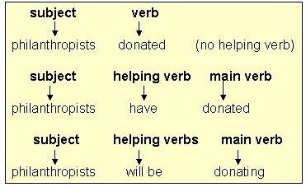
IMPORTANT NOTE: To be a predicate, a verb that ends in –ing must ALWAYS have a helping verb with it. An –ing verb WITHOUT a helping verb cannot be a predicate in a sentence.
More About Predicates
A predicate usually follows the subject, but it may be separated from the subject by one or more words.
Look at this sentence.
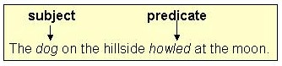
Even though hillside is next to the verb howled, it is not the subject here because it is not DOING the howling. The dog is.
Sometimes the verbs in the predicate may be separated from one another.
Look at these sentences.
1.
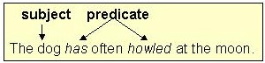
The word often is an adverb, not a helping verb. The predicate is has howled.
2.
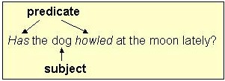
Example #2 illustrates that when we form questions, we sometimes make the subject separate the helping verbs from the main verb.
When separations like #1 and #2 occur, don’t be alarmed or confused. Just remember the rules for finding the subject and predicate. You should have no difficulty at all.
In some cases as well, the subject may NOT DO the action of the predicate, but may, instead, be acted upon by the predicate.
Example
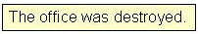 office = subject
was destroyed = predicate
NOTE that the noun, office, is NOT the DOER of the action (was destroyed).
Instead, office is being acted upon (is being destroyed) by some unknown DOER.
In such a case, office is still the subject of the predicate was destroyed.
Even when the DOER of the action is known, it is not the subject unless it is working in a partnership with the verb.
Example
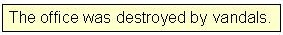 office = subject
was destroyed = predicate
Vandals is NOT the sentence’s subject because vandals is not working in a partnership with the verb was destroyed.
We use the term passive voice to refer to the predicate in this kind of subject-verb partnership.
SOME FINAL WORDS . . .
The terms subject and predicate can be applied ONLY where there is a noun-verb partnership, where the noun and verb interact with one another to create the topic of the sentence.
You will NEVER see a subject sitting alone without a predicate (although you may see a noun sitting alone without a verb.)
You WILL see a predicate sitting alone without a subject ONLY when the subject is you (understood).
In order to be a predicate, a verb ending in –ing MUST HAVE a helping verb.
REVIEW OF SUBJECT – PREDICATE TRICKY SPOTS:
1. You (understood) subject
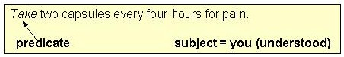
2. Subject separated from predicate
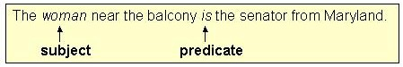
3. Parts of predicate (helping verb / main verb) separated by adverb
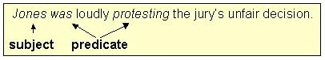
4. Subject – predicate order changed in a question
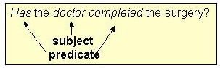
5. Subject – predicate pair in passive voice
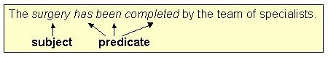
Exercise 2
Directions: Nouns (or pronouns) and verbs have been underlined in the sentences below. For each underlined word, choose if it is a subject or predicate. If it is not a subject or predicate, choose neither.
1. Deep, heavy snows cover these mountains in winter.
2. Expeditions to the Southwest challenged his ideas about the location of minerals.
3. Knowing that information, you should not have any trouble.
4. Will you be arriving on the 10:20 train?
will be arriving (is one)
5. Please eat your spinach.
Part 3
Now that you understand nouns/pronouns, verbs, subjects, and predicates (WORDS), you are ready to move up to a larger segment: phrases.
A phrase is a group of words which may contain noun/pronouns or verb forms, but does NOT contain a subject or a predicate.
**REMEMBER: Every subject has a predicate, and every predicate has a subject. These two functions never appear without each other. They form a partnership, a team.
Some examples of PHRASES:
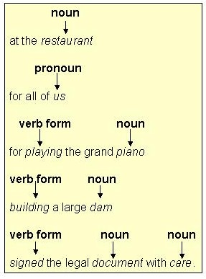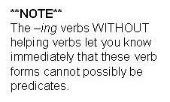
Even though these phrases contain nouns (pronouns) or verb forms, or both nouns (or pronouns) and verb forms, none of the nouns/pronouns/verbs have the qualifications needed to be subjects or predicates. None of them work as a partnership – as a team.
Also, these phrases do NOT seem to say anything complete either.
These findings lead to a definition of the phrase:
A phrase is a group of related words that
1. does not express a complete thought
2. does not have a subject and predicate pair
Exercise 3
Directions: For each sentence below, tell whether the underlined group of words contains a subject and predicate, or whether it is just a phrase. Indicate your answers by selecting S and P for subject and predicate, or by writing phrase.
1. Looking around the room, Marcia shouted out the good news about the treaty.
S and P -- Phrase
2. Free tickets were given to every person in line by 6:00 a.m.
S and P -- Phrase
3. Occasionally Marion prefers cigars to cigarettes.
S and P -- Phrase
4. Instead of relying on the draft, some countries use a lottery system for determining military service.
S and P -- Phrase
5. After all those hours of hard work, will you finally be finished?
S and P -- Phrase
Part 4
We can now look at a more complicated concept: clauses.
Words and phrases can be put together to make clauses.
Like a phrase, a clause is a group of related words.
Unlike a phrase, a clause DOES contain a subject and predicate.
Note the difference between phrases and clauses in the following examples:
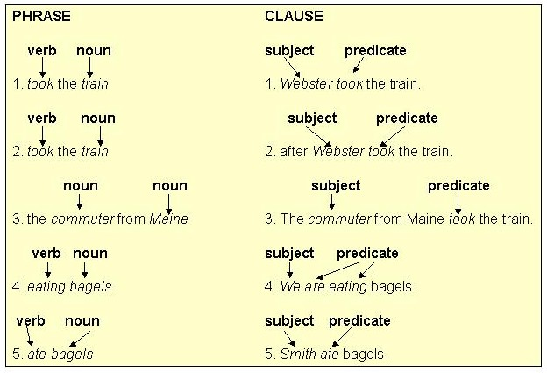
The words below are a phrase, NOT a clause. This means that the noun, Smith, is NOT a subject and that the verb form, eating, is NOT apredicate. Why can’t these two words possibly be subject and predicate?
You probably noticed that, of the five clause examples given earlier in Section 5, only three were sentences (#1, 3, 4).
Look back at all five clause examples. Read each one to yourself.
Did you notice any difference in the meaning between the three clauses that ARE sentences (#1, 3, 4) and the two clauses (#2, 5) that are NOT sentences?
Yes, there is a difference!
Clauses #1, 3, and 4 give a thought or an idea that is COMPLETE, that can stand by itself, independent of other words.
However, clauses #2 and 5 give only an INCOMPLETE thought or idea, one that cannot stand independent by itself, one that needs some more words to make it whole.

To see the difference, look at clauses #1 and 2 copied below for you.
1.
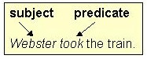
This clause tells us what happened and who made it happen. Its thought is COMPLETE and finished. We are not left “hanging” or asking questions after a clause like this one
2.
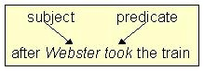
This clause tells us what happened and who made it happen, BUT its thought is NOT complete.
The word after changes the clause meaning, making it INCOMPLETE.
After reading this clause, we are left “hanging” – left waiting for it to be finished. This clause raises a question: What happened after Webster took the train?
These two clauses illustrate the two kinds of clauses we use in the English language:
independent clauses and dependent clauses
Clause #1
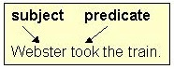
Clause #1 has these three characteristics:
1. subject 2. predicate 3. complete thought
This kind of clause is called an independent clause or a main clause. It is a complete unit by itself and does NOT need or depend upon any other words for its completeness.

FOR YOUR INFORMATION . . .
AN INDEPENDENT CLAUSE AND A SIMPLE SENTENCE ARE THE SAME THING.
Clause #2
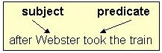
Clause #2 has these three characteristics:
1. subject 2. predicate 3. incomplete thought
This kind of clause is called a dependent clause or a subordinate clause. It is an incomplete unit on its own, leaving its reader asking questions. It needs or depends on additional words to be a complete thought.

We can now formulate a definition for each type of clause:
An independent clause is a group of words that contains a subject, a predicate, and a complete thought.
A dependent clause is a group of words that contains a subject and a predicate, but does NOT express a complete thought.
Exercise 4
Directions: Identify each clause below as independent (I) or dependent (D).
1. after you feed the dog
independent -- dependent
2. the instructor showed me some slides
independent -- dependent
3. when the instructor showed me some slides
independent -- dependent
4. when will the instructor show me some slides
independent -- dependent
5. she showed some slides
independent -- dependent
Part 5
You have now reached the main focus of this unit: writing complete sentences.
You will be happy to know that while you have been progressing from word to phrase to clause, you have actually already been teaching yourself about sentence structure!
Here’s the good news. In order to have a sentence, you need only TWO elements:
1. a subject-predicate unit AND 2. a complete thought
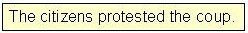 citizens = subject
protested = predicate
complete thought? yes
In other words, a simple sentence is actually the SAME thing as an independent clause. Since you already know what an independent clause is, you can also understand immediately what a simple sentence is.
SIMPLE SENTENCE = INDEPENDENT CLAUSE
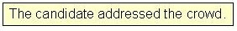 =
Therefore, as long as you remember what constitutes an independent clause, you will automatically recognize what constitutes a simple sentence.
REMEMBER: subject -- predicate pair + complete thought = simple sentence

BACK TO DEPENDENT CLAUSES AND PHRASES FOR A MOMENT . . .
Dependent clauses and phrases are called sentence fragments because they are missing one or more parts needed to make a sentence (subject/predicate pair & complete thought) and are, therefore, only pieces or fragments of complete sentences.
Look at these examples
1.
= 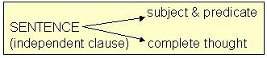
2.
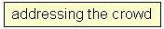 = 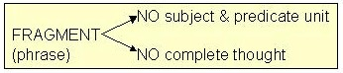
3.
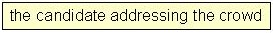 = 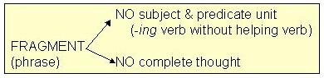
4.
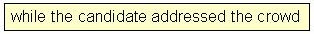 = 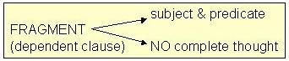
Examples 2, 3, and 4 are fragments, not complete sentences, because they are missing at least one element needed to construct a complete sentence.
Except in rare instances, fragments are MAJOR WRITING ERRORS. Try not to use fragments in your writing. Use complete sentences instead.
Exercise 5
Directions: Some of the following groups of words are only fragments (phrases or dependent clauses) while others are simple sentences (independent clauses). For each item, indicate whether it is a fragment or a sentence.
NOTE: No capital letters or end punctuation marks have been used here to indicate whether a particular item is a sentence or a fragment. Use the subject – predicate units and complete thoughts to determine your answers.
1. since she is an intelligent person
fragment -- sentence
2. he often puts colorful advertisements on my desk
fragment -- sentence
3. when afternoon arrives, at about 1:00 p.m.
fragment -- sentence
4. the psychology instructor giving an exam
fragment -- sentence
5. whether Smith witnessed the accident or not
fragment -- sentence
6. as we were driving to Washington
fragment -- sentence
7. for example, a novel by Anne Tyler
fragment -- sentence
8. you shouldn’t read without your glasses
fragment -- sentence

